**DAILY ONLINE ACTIVITIES SUMMARY**

|  |  |  |  |  |  |  |  |  |
| --- | --- | --- | --- | --- | --- | --- | --- | --- |
| **Date:** | **07-06-2020** | | | | | **Name:** | **Anusha** | |
| **Sem & Sec** | **VIII Semester & A Section** | | | | | **USN:** | **4AL16CS014** | |
| **Online Test Summary** | | | | | | | | |
| **Subject** | | **No Test was Conducted** | | | | | | |
| **Max. Marks** | | **-** | | **Score** | | | **-** | |
| **Certification Course Summary** | | | | | | | | |
| **Course** | **Introduction to Hadoop & Robotic Process Automation** | | | | | | | |
| **Certificate Provider** | | | **Great Learning & Ui Path** | | **Duration** | | | **4 Hours & 3 Hours** |
| **Coding Challenges** | | | | | | | | |
| **Problem Statement: Factorial of a number using recursion.** | | | | | | | | |
| **Status: COMPLETED** | | | | | | | | |
| **Uploaded the report in Github** | | | | | **YES** | | | |
| **If yes Repository name** | | | | | **anushasuvarna-14** | | | |
| **Uploaded the report in slack** | | | | | **YES** | | | |

Online Test Details:

NIL

Certification Course Details:

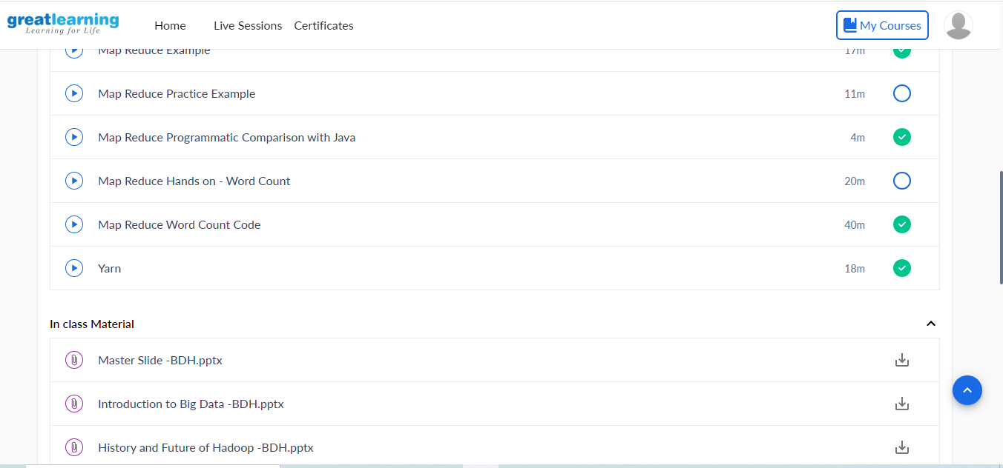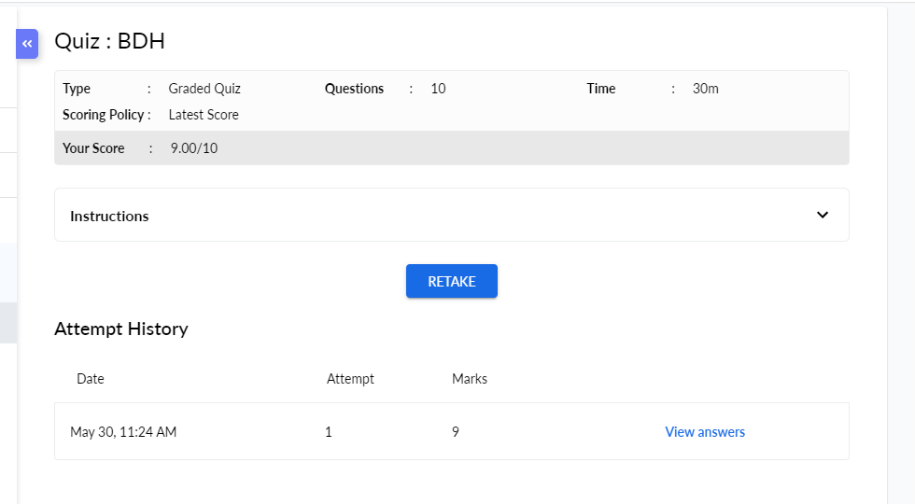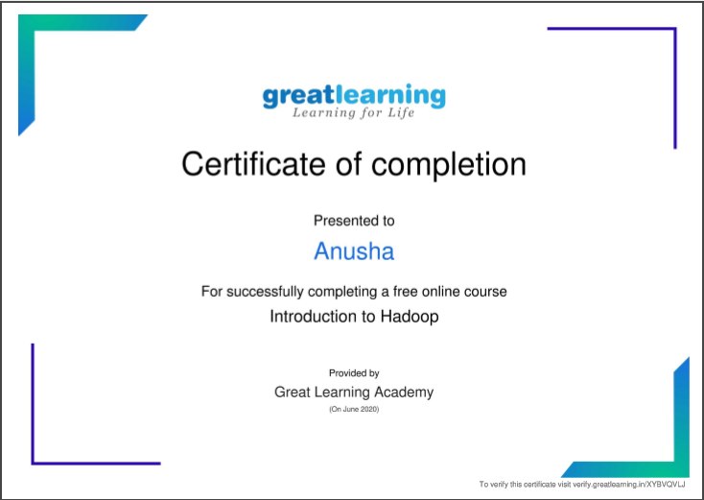

Coding Challenges Details:

**#include<stdio.h>**

**long int multiplyNumbers(int n);**

**int main() {**

**int n;**

**printf("Enter a positive integer: ");**

**scanf("%d",&n);**

**printf("Factorial of %d = %ld", n, multiplyNumbers(n));**

**return 0;**

**}**

**long int multiplyNumbers(int n) {**

**if (n>=1)**

**return n*multiplyNumbers(n-1);**

**else**

**return 1;**

**}**